**IOT BASED SMART STREET LIGHT**

**A PROJECT REPORT**

###### **Submitted by**

##### ***Bhushan Mahajan*** *(19MIM10074)*

***Shashwat Jha*** *(19MIM10111)*

***Himanshu***  *(19MIM10085)*

***Mayank Samadhiya*** *(19MIM10077 )*

**INTEGRATED MASTER OF TECHNOLOGY**

*in*

# **COMPUTER SCIENCE AND ENGINEERING**

*Specialization in*

***Artificial intelligence and machine learning***



**SCHOOL OF COMPUTING SCIENCE AND ENGINEERING**

**VIT BHOPAL UNIVERSITY**

**KOTHRI KALAN, SEHORE**

**MADHYA PRADESH - 466114**

##### NOV 2020

**VIT BHOPAL UNIVERSITY,KOTHRI KALAN, SEHORE**

**MADHYA PRADESH – 466114**

**BONAFIDE CERTIFICATE**

Certified that this project report titled **“IOT BASED SMART STREET LIGHT”** is the bonafide work of “**SHASHWAT JHA (19MIM10111), MAYANK SAMADHIYA (19MIM10077), HIMANSHU (19MIM10085), BHUSHAN MAHAJAN (19MIM10085)”** who carried out the project work under my supervision. Certified further that to the best of my knowledge the work reported here does not form part of any other project / research work on the basis of which a degree or award was conferred on an earlier occasion on this or any other candidate.

**PROGRAM CHAIR PROJECT GUIDE**

Dr. Pandimurugan Vellaisamy, Dr.Sampath Kumar,

Assistant Professor Assistant Professor

School Of AI & ML Division School Of AI & ML Division

VIT BHOPAL UNIVERSITY VIT BHOPAL UNIVERSITY

The Project Exhibition I Examination is held on _______________

**ACKNOWLEDGEMENT**

First and foremost I would like to thank the Lord Almighty for His presence and immense blessings throughout the project work.

I wish to express my heartfelt gratitude to Dr. Nageswara Guptha M, Head of the Department, School of Aeronautical Science for much of his valuable support and encouragement in carrying out this work.

I would like to thank my internal guide Dr.Sampath Kumar,for continually guiding and actively participating in my project, giving valuable suggestions to complete the project work.

I would like to thank all the technical and teaching staff of the School of Computer Science and Engineering, who extended directly or indirectly all support.

Last, but not the least, I am deeply indebted to my parents who have been the greatest support while I worked day and night for the project to make it a success.

**LIST OF ABBREVIATIONS**

|  |  |  |
| --- | --- | --- |
| **1** | **IR** | **INFRA RED** |
| **2** | **LED** | **LIGHT-EMITTING DIODE** |
| **3** | **IoT** | **Internet Of Things** |
| **4** | **SSLS** | **SMART STREET LIGHT SYSTEMS** |

**LIST OF FIGURES**

|  |  |  |
| --- | --- | --- |
| **FIGURE NO.** | **TITLE** | **PAGE NO** |
| **1** | **WI-FI MODULE** | **18** |
| **2** | **INTEGRATION OF WIFE MODULE WITH ARDUINO** | **19** |
| **3** | **ARDUINO** | **20** |
| **4** | **INTEGRATION OF IR SENSOR ,WI-FI MODULE AND BREADBOARD** | **20** |
| **5** | **INTEGRATION OF ARDUINO WITH IR SENSORS** | **21** |
| **6** | **CIRCUIT DIAGRAM** | **21** |

**LIST OF TABLES**

|  |  |  |
| --- | --- | --- |
| **TABLE NO.** | **TITLE** | **PAGE NO.** |
| **1** | **RESULT PART** | **26** |
|  |  |  |

**ABSTRACT**

The aim of automated streetlight management systems using IOT is the conservation of energy by reducing electricity wastage as well as to reduce the manpower. Streetlights are the elemental part of any city since it facilitates better night visions, secure roads, and exposure to public areas but it consumes a quite large proportion of electricity. In the manual streetlight system lights are powered from sunset to sunrise with maximum intensity even when there is sufficient light available. This energy wastage can be avoided by switching off lights automatically. The saved energy can be efficiently utilized for other purposes like residential, commercial, transportation etc. This can be achieved using an IOT enabled streetlight management system. The project uses Light Emitting Diodes (LED) that do not consume an enormous amount of electricity to replace the power consuming traditional HID lamps. LED lights along with LDR enables the intensity variation which is infeasible with the HID lamps. As LEDs are directional light sources it can emit light in specific directions thereby optimizing the efficiency of the streetlights. This system includes an additional DHT11 Temperature-Humidity sensor. This provides the exact temperature and humidity of a particular region. DHT11 is a composite sensor that contains a calibrated digital signal output of the temperature and humidity. It ensures high reliability and excellent long-term stability. This work is implemented using a programmed Arduino board for providing the required intensity of light at various times. The proposed work has achieved a better performance compared to the existing system.

**TABLE OF CONTENTS**

|  |  |  |
| --- | --- | --- |
| **CHAPTER NO.** | **TITLE** | **PAGE NO.** |
|  | List of Abbreviations  List of Figures  List of Tables  Abstract | iv.  v.  vi    vii. |
| 1 | **INTRODUCTION** Introduction 1.2 Motivation for the work  1.3 [About Introduction to the project  including techniques]  1.5 Problem Statement  1.6 Objective of the work  1.7 Organization of the thesis |  |
| 2 | **LITERATURE SURVEY**    2.1 Existing Algorithms    2.2 Research issues/Observations from  literature Survey |  |
| 3 | **SYSTEM ANALYSIS**    3.1 Introductions   |  | | --- | | 3.2 Disadvantages/Limitations in the Existing System  3.3 Proposed Systems | |  |
| 4 | **SYSTEM DESIGN AND IMPLEMENTATION**    4.1 Introduction  4.2 Module 1 design & Implementation |  |
| 5 | **PERFORMANCE ANALYSIS**  5.1 Performance Measures (Table/text) |  |
| 6 | **FUTURE ENHANCEMENT AND CONCLUSION**  6.1 Limitation/Constraints of the System  6.2 Future Enhancements  6.3 Conclusion |  |

**1. INTRODUCTION**

**1.1 INTRODUCTION**

This new system is a result of Thinking about the huge power consumption of the present lighting system that consumes over world’s 79.3% of the world's electricity and also the human intervention. This IOT based Street light automation is a project on smart and automated light control to control the problem of power consumption and usage of the streets manually, late in the night. Street lights today are getting replaced by LED street lighting systems, which reduces the power consumption to a great extent. Also, this system removes the human intervention resulting in the fully automated street light system. Another advantage of LEDs is the ease with which strength of the light can be controlled. Hence, automation and movement detection based street light control can be designed easily and operable.

**1.2 MOTIVATION OF THE WORK**

The present street lightning framework has many problems which need to be worked upon. The Problem with the present framework is that it requires human intervention to make the system to operate. In Bad weather conditions, the timing of street lights ON/OFF differ discernibly which is one of the main problems of the present street lights systems. Due to human intervention sometimes street lights are ON most of the day without any purpose because these are manually operable and this causes huge amounts of power loss meaninglessly. With the wide acceptability of energy conserving and sustaining technologies like light emitting diode (LED) lights and quick response system, dependable working, and power saving street lighting system getting into reality. The reason for this is to showcase the Smart automated Street Lighting System. The only aim of this research paper is to describe an automated lighting framework which focuses on the energy saving and reducing human intervention, and also to construct a smart street lighting system with sensors and controllers, to outline an automated lighting system with particular methodology plan, which makes the system more user friendly and that requires less involvement of manpower.

**1.3 OUR IDEA FOR PROJECT**

All we know is that The current system of street lights consists of manual controls which need Human intervention . This causes the loss of energy due to manual control, so for energy saving we are implementing IOT Based Smart Street Light Management System .These systems are designed in such a way that they could reduce their intensity of light and save energy as much as possible.

**1.4 PROBLEM STATEMENT**

In most of the cities, the street lights are ON when it is not needed and It is OFF when is not needed. Because of these situations the huge energy expenses for a city gets wasted. Usually the lights are ON in the evening after the sunset, it continues to be ON till the sun rises in the next day morning.

**1.5 OBJECTIVE OF WORK**

By use of this system, we will try to control street lights from the remote server. The primary objective is to develop an efficient Street Light System.

i) To provide wireless access for handling it.

ii) Need some Server which can be used to monitor the whole city’s street lights.

iii) Low-cost Internet technology can be used for remote access.

**1.6 ORGANIZATION OF THE THESIS**

Chapter 1: Introduction

Chapter 2: Literature Survey

Chapter 3: Project Procedure

Chapter 4: Work done

Chapter 5: Observation

Chapter 6: Result & Conclusion

Chapter 7: Recommendation for future work

Chapter 8: References

**2. LITERATURE REVIEW**

**2.1 EXISTING ALGORITHM**

More than 27 million street lights light up the nights in India.It consumed as 20% to 40% of total energy consumption.It may be considered as a major component in electricity consumption.During day time due to some fault Some street lights remain ON and OFF due to this huge amount of Electricity is wasted. It is sometimes difficult for repairing a particular street lamp because sometimes it is not trackable easily.

**2.2 RESEARCH ISSUE/OBSERVATIONS FROM LITERATURE SURVEY**

**Reference From:- International Research Journal of Engineering and Technology (IRJET)**

**IOT BASED DYNAMIC CONTROL OF STREET LIGHTS FOR SMART CITY**

**Snehal Bhosale ,Komal Gaware ,Pradnya Phalke ,Dipali Wadekar, Pallavi Ahire**

**Student, Dept. of Information Technology, Sinhgad Institute of Technology, Lonavala, Maharashtra, India**

* ESP 8266 wireless module is used for street light controlling Their aim is to monitor the vitality of street lights and forward monitored returns to the control station. Inside the lamp module, it consists of light dependent resistors (LDR) module, microcontroller module and the transmission module.
* Optimisation of a standalone street light system with consideration of lighting control. This paper aims at designing and executing the advanced development of embedded systems for energy saving of street lamps. Nowadays, the human has become too busy and is unable to find time even to switch the lights wherever not necessary. This paper gives the best solution for electrical power wastage.
* E-Street zone-automatic Street light based on the movement of vehicles. Every street light can be integrated with an IR sensor which detects the movement of vehicles. When the vehicle passes, light gets illuminated. Due to this electricity can be consumed less and energy can be saved up to some extent
* The efficient control algorithm for a smart solar street light.

This proposed system works on solar energy. The street light gets charged on sun energy in the daytime, and it is consumed at night. The sensors get automatically ON in the darkness and OFF in daytime.

**3. SYSTEM ANALYSIS**

**3.1 INTRODUCTION**

Currently, more than 27 million street lights light up the nights in India. Most of these are CFL, metal halides or sodium vapor lights. Various sources place the demand of electricity for these street lights as anywhere between 20 to 40% of the energy produced in India.

**3.2 DISADVANTAGES/LIMITATIONS IN THE EXISTING SYSTEM**

#### 

#### **3.2.1 Faulty lights**

Firstly, there is no baseline data to understand how many faulty lights are in the field. Next issue is that there is no data to understand which make of lights work or which don’t and their lifetime. There is a good chance that a particular manufacturer is not suitable for India, or that while a particular brand is cheap to acquire, they have a high failure rate.

#### **3.2.2 Electricity theft**

Electricity theft is a huge problem in India. There is no data on the amount of electricity consumed by each light, or on a broader level, even how much a phase consumes; thus, there is no way of determining if there is a leak somewhere in the line. However, this can be combated using analytics and an IoT based remote monitoring solutions, which will allow the government to find how much electricity is being siphoned off via illegal methods.

#### **3.2.3 Unnecessary usage**

Despite being an electricity deficient country, it is common to see street lights working even during the day. This leads to wastage of electricity. In order to understand how much energy is wasted, and how it can be stopped, analytics is needed, yet again.

We Took This Project To Implement the Artificial Technology Using Internet of Thing (IoT) with Streetlight To Make them "Smart Streetlights".​

**3.3 PROPOSED WORK**

Through This Project, We Could Achieve:-​

We Could Get Alerts Related To Any Damage or Fault Of Each Particular Streetlight through The Application to the Servers like Some Lights Remained ON in Daytime, or Bulb Issue. Thus It Help Us In Getting Each And Every Live Update.​

Keeping A track On Electricity Consumption Of Every Particular Streetlight And Thus Would Be Help In Optimizing Electricity Bills.​

Resolving Any Technical Issue like Sorting the Faulty Streetlight would be easier Through The Application.Thus It Would Be Very Effective in Saving Electricity & Manpower ,Faster Resolution and Reducing Time.​

We Could Also Integrate It With CCTV, Traffic Lights, Emergency Button For A Perfect Surveillance Of The Traffic By Server Rooms.​

**4. SYSTEM DESIGN AND IMPLEMENTATION**

**4.1 INTRODUCTION**

The **ESP8266** is a low-cost [Wi-Fi](https://en.wikipedia.org/wiki/Wi-Fi) microchip, with a full [TCP/IP stack](https://en.wikipedia.org/wiki/TCP/IP_stack) and [microcontroller](https://en.wikipedia.org/wiki/Microcontroller) capability, produced by [Espressif Systems](https://en.wikipedia.org/w/index.php?title=Espressif_Systems&action=edit&redlink=1) in Shanghai, China.The chip first came to the attention of Western [makers](https://en.wikipedia.org/wiki/Maker_culture) in August 2014 with the **ESP-01** module, made by a third-party manufacturer Ai-Thinker. This small module allows microcontrollers to connect to a Wi-Fi network and make simple TCP/IP connections using [Hayes](https://en.wikipedia.org/wiki/Hayes_command_set)-style commands. However, at first there was almost no English-language documentation on the chip and the commands it accepted. The very low price and the fact that there were very few external components on the module.

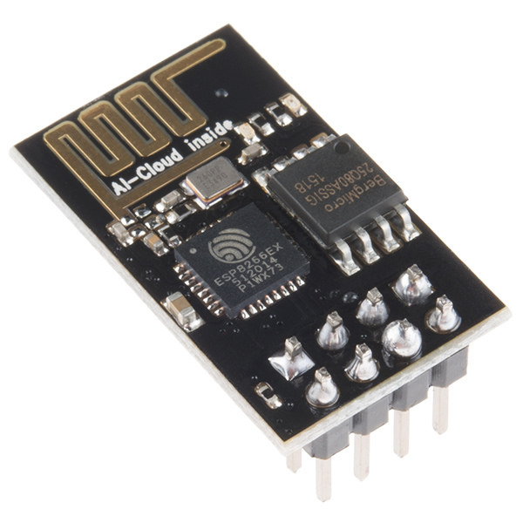

**1.WIFI-MODULE**

**4.2 MODULE DESIGN AND IMPLEMENTATION**

The lighting comes from LED bulbs, which are triggered by multi sensors. A person, object/vehicle appears nearby the sensors, It captures the signals and turns ON the particular street lights. When an object moves, lights automatically work. SSLS used to save energy, mainly helps to save power. IR LED lights dependent devices whose resistance decreases when light falls on them and increases in the dark. When a light dependent resistor is kept in dark, its resistance is very high. The vehicle which passes by the street light is detected by an IR sensor. Relays are used as a switch to switch on/off the street light bulb.

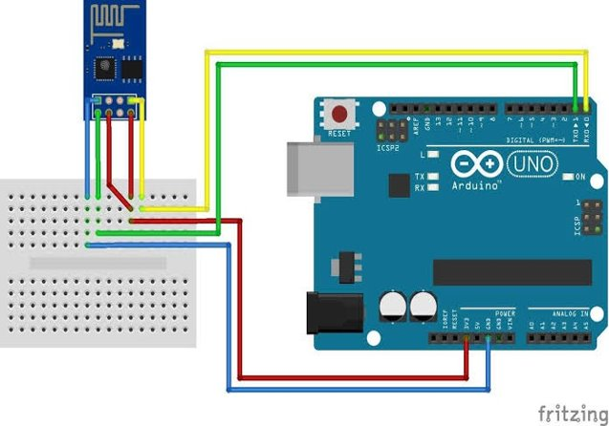

**2. INTEGRATION OF WI-FI MODULE WITH ARDUINO IDE​**

**5.PERFORMANCE ANALYSIS**

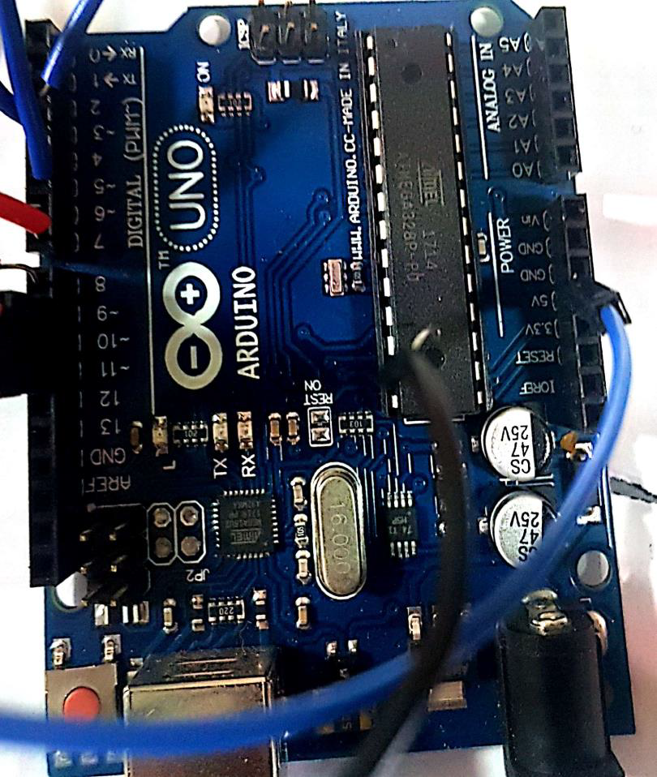

**3.ARDUINO**

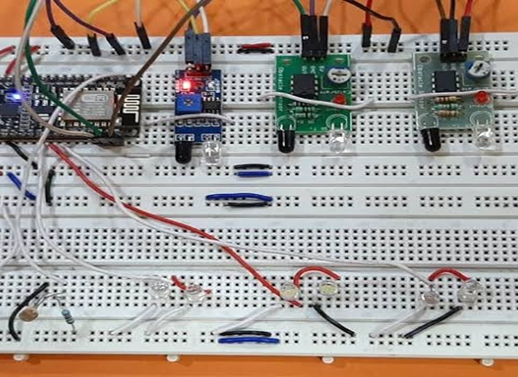

**4.INTEGRATION OF IR SENSOR ,ARDUINO AND BREADBOARD**

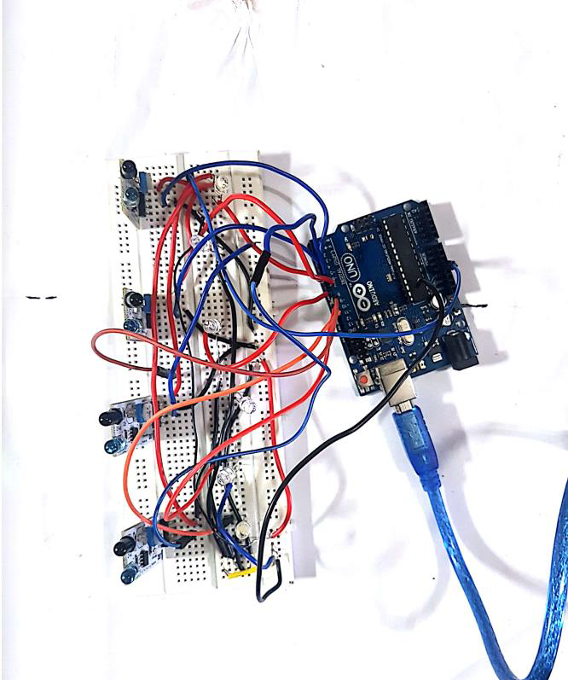

**5.INTEGRATION OF ARDUINO WITH IR SENSORS**

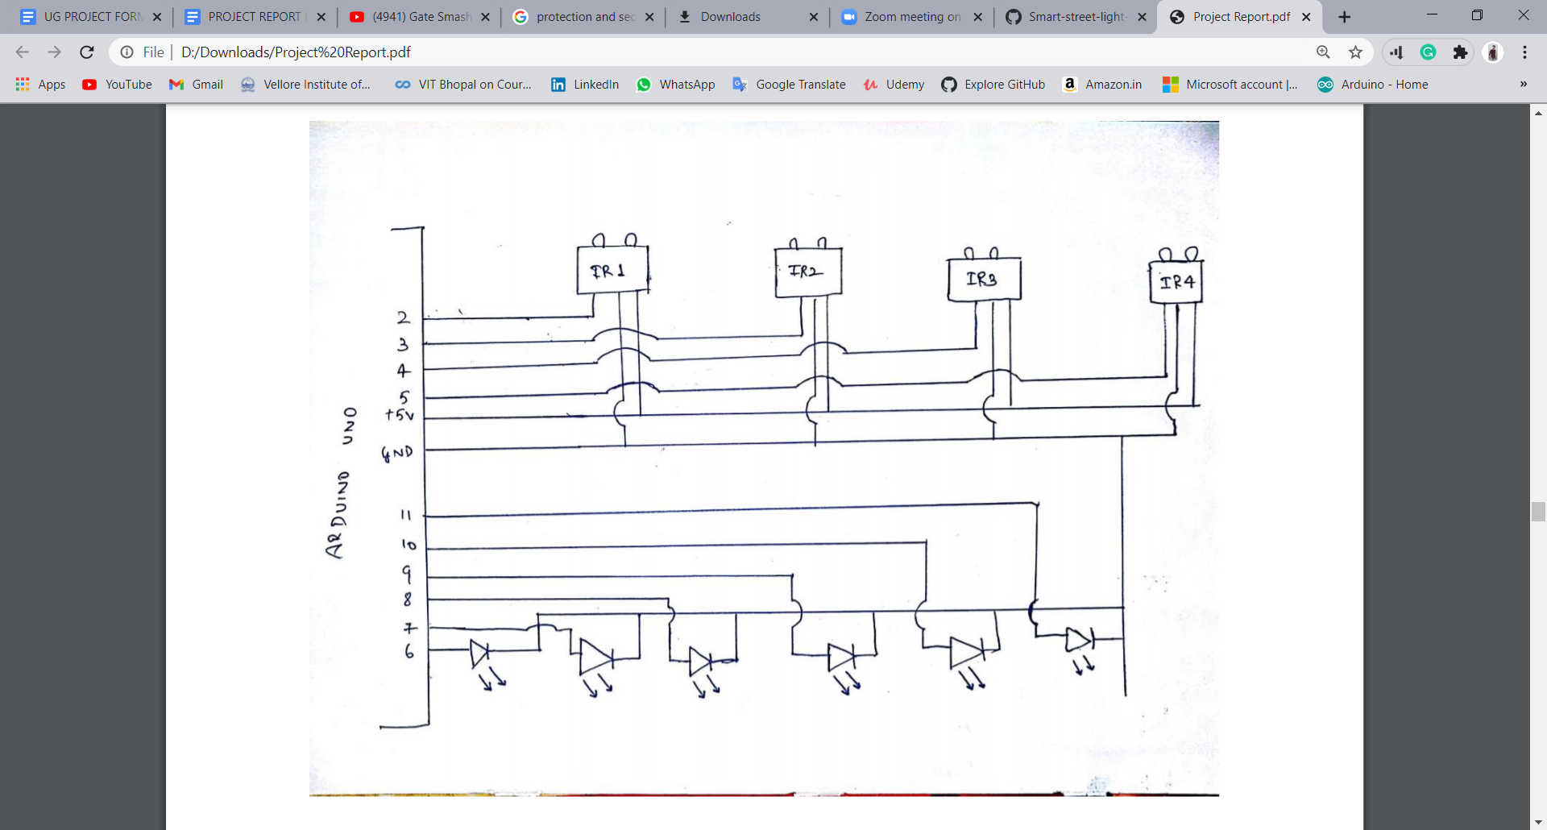

**6.CIRCUIT DIAGRAM**

**CODING PART: -**

int led = 2;

int led1 = 3;

int led2 = 4;

int led3 = 5;

int led4 = 6;

int ldr = A5;

int ir = A0;

int ir1 = A1;

int ir2 = A2;

int ir3 = A3;

int ir4 = A4;

void setup()

{

Serial.begin (9600);

pinMode (led,OUTPUT);

pinMode (led1,OUTPUT);

pinMode (led2,OUTPUT);

pinMode (led3,OUTPUT);

pinMode (led4,OUTPUT);

pinMode (ldr,INPUT);

pinMode (ir,INPUT);

pinMode (ir1,INPUT);

pinMode (ir2,INPUT);

pinMode (ir3,INPUT);

pinMode (ir4,INPUT);

}

void loop()

{

Serial.println(analogRead(A5));

int ldrStatus = analogRead (ldr);

if (ldrStatus <=500)

{

digitalWrite(led, HIGH);

analogWrite(led,255/5);

digitalWrite(led1, HIGH);

analogWrite(led1,255/5);

digitalWrite(led2, HIGH);

analogWrite(led2,255/5);

digitalWrite(led2, HIGH);

analogWrite(led2,255/5);

if (analogRead(A0)<300) // IR 1 CODE

{

digitalWrite(led,HIGH);

analogWrite(led,255);

delay(1000);// microsecond

}

else

{

digitalWrite(led,HIGH);

analogWrite(led,255/5);

}

if (analogRead(A1)<300) // IR 1 CODE

{

digitalWrite(led1,HIGH);

analogWrite(led1,255);

delay(1000);// microsecond

}

else

{

digitalWrite(led1,HIGH);

analogWrite(led1,255/5);

}

if (analogRead(A2)<300) // IR 2 CODE

{

digitalWrite(led2,HIGH);

analogWrite(led2,255);

delay(1000);// microsecond

}

else

{

digitalWrite(led2,HIGH);

analogWrite(led2,255/5);

}

if (analogRead(A3)<300) // IR 2 CODE

{

digitalWrite(led3,HIGH);

analogWrite(led3,255);

delay(1000);// microsecond

}

else

{

digitalWrite(led3,HIGH);

analogWrite(led3,255/5);

}

if (analogRead(A4)<300) // IR 2 CODE

{

digitalWrite(led4,HIGH);

analogWrite(led4,255);

delay(1000);// microsecond

}

else

{

digitalWrite(led4,HIGH);

analogWrite(led4,255/5);

}

}

else

{

digitalWrite(led1, LOW);

digitalWrite(led2, LOW);

digitalWrite(led3, LOW);

digitalWrite(led4, LOW);

}

}

**We are Using Different Vehicles For Analysis Of Our Project-**

|  |  |  |
| --- | --- | --- |
| **SERIAL NUMBER** | **VEHICLE NAME** | **SINGLE WAY TIME TAKEN**  **(IN SECOND)** |
| **1** | **AUTO** | **3 SECOND** |
| **2** | **JEEP** | **4 SECOND** |

**6.FUTURE ENHANCEMENT AND CONCLUSION**

**6.1 LIMITATION/CONSTRAINTS OF PROPOSED SYSTEMS**

The automatic street light system requires a higher initial investment in comparison

to conventional street lights.

● Generation of energy for solar street light entirely depends upon the climatic

conditions.

● Risk of theft of the automatic street light system is relatively higher since they are

non-wired & are much expensive.

● Rechargeable batteries of the automatic street light system are required to be

replaced a few times.

● Dust or moisture can accumulate of PV panels which can hinder /energy production

**6.2 FUTURE ENHANCEMENT**

* Automatic switching of street lights​
* Maintenance cost reduction​
* Reduces electricity wastage.​
* Wireless communication​
* Energy saving​
* Reduction of manpower​
* Reduce energy consumption by up to 50%​
* Controlling of street lights made much easier.

**6.3 CONCLUSION**

The Important Aim of using IOT Based Smart Street Light we can save upto 50% of electricity through our regular usage it also helps in making the city a "Smart City" ​

The System Solves the energy efficiency problem of conventional solar-powered street lamp system, ensure the traffic safety and prevent crime against night-time.​

The Smart Streetlight System Will Be Very Useful from Small Streets To Highway, and Public Places like Hotels, Industries.​

It will Control the overflow of Current. ​Manpower is Very Less required In this System.

**REFERENCES​**

[**https://analyticsindiamag.com/smart-cities-optimize-street-lighting-india/**](https://analyticsindiamag.com/smart-cities-optimize-street-lighting-india/)

[**https://www.arduino.cc/**](https://www.arduino.cc/)

[**https://en.wikipedia.org/wiki/ESP8266**](https://en.wikipedia.org/wiki/ESP8266)

<https://www.sunrom.com/p/infrared-sensor-board>

<https://youtu.be/2cjufbgOBYo>